# MAT 243 Project One Summary Report

Joey Labine McCrary II

Joey.mccrary@snhu.edu

Southern New Hampshire University

## Introduction: Problem Statement

Choose a NBA team and analyze their data from a given time frame. Compare the results with the data from an assigned team from another given time frame. From both data sets perform a statistical analysis using Normal Distribution methods.

## Introduction: Your Team and the Assigned Team

A NBA analyst has to analyze a historical data set of the ’13-’15 Lakers. Results will be used in decisions concerning the team’s performance. Management and staff has also requested a study be conducted of the distribution of key variables associated with the performance of the ’96-’98 Chicago Bulls. The results will then be compared with the Lakers.

Table 1. Information on the Teams

|  | **Name of Team** | **Assigned Years** |
| --- | --- | --- |
| 1. Yours | Los Angeles Lakers | 2013 – 2015 |
| 2. Assigned | Chicago Bulls | 1996 – 1998 |

## Data Visualization: Points Scored by Your Team

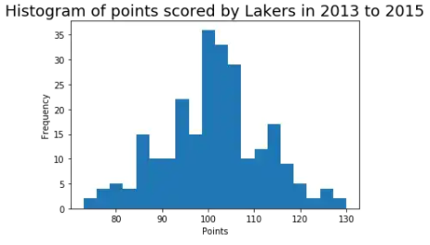

The data set contains 246 entries of points scored with matching elo_n. This rating, elo_n, is a measure of relative skill level that takes into account the other statistics of the data set.

Due to its size, the histogram will be more user-friendly; it expresses final scores against score frequencies. The histogram gives better data visualization organizing data into an easily identifiable pattern.

## Data Visualization: Points Scored by the Assigned Team

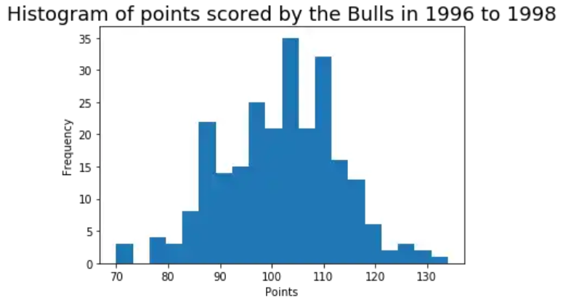

Histogram was chosen for the ’96-’98 Bulls using the same logic as above.

## Data Visualization: Comparing the Two Teams

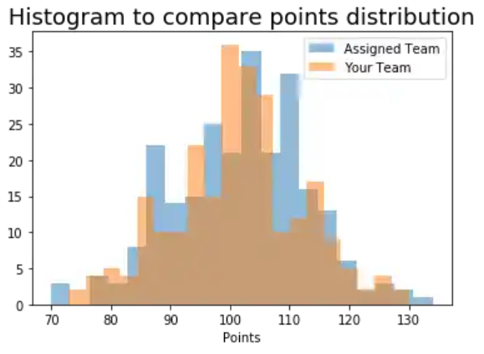

Both data sets individually have been proven best displayed by the histogram and comparing the two should be consistent and continue using the established variables. Overlapping of plots with different colors allow visuals for both data sets showing the Lakers more unimodal.

## Descriptive Statistics: Relative Skill of Your Team

Table 2. Descriptive Statistics for Relative Skill of Your Team

| **Statistic Name** | **Value** |
| --- | --- |
| Mean  Median  Variance  Standard Deviation | 1440.49  1412.34  6337.75  79.61 |

Descriptive statistics are used to measure central tendency and variability of data distribution and useful over large data sets. They can express general trendiness to represent an entire data set. Mean is the average of relative skill ratings from 2013 - 2015, with median being the center of a numerically sorted data set. The mean and median of the data are close signifying bell-shaped skewedness. While the median is close, the mean is a better measure for central tendency. Variance is the average of the squared difference between the mean and data set. Standard deviation is the square root of variance.

## Descriptive Statistics: Relative Skill of the Assigned Team

Table 3. Descriptive Statistics for Relative Skill of the Assigned Team

| **Statistic Name** | **Value** |
| --- | --- |
| Mean  Median  Variance  Standard Deviation | 1739.80  1751.23  2651.55  51.49 |

The descriptive statistics here have the same meaning as above and similar relationship exists for central tendency. Variance and standard deviation are greater in the data set for the comparative team, the Chicago Bulls. Since, the Bulls’ variability is lower, then they would be the team with more consistent skill. Less variability is more consistency.

## Confidence Intervals: Average Relative Skill of All Teams in Lakers’ Years

Table 4. Confidence Interval for Average Relative Skill of Teams in Lakers’ Years

| **Confidence Level (%)** | **Confidence Interval** |
| --- | --- |
| 95% | (1502.02, 1507.18) |

Confidence intervals are used to estimate central tendency combining range with probability. The 95% confidence interval here is high and does not contain the mean elo_n for the Lakers, making them an outlier. Probability of a team’s relative skill level being less than the Lakers is 0.2853 which is low and consistent with the mean being less and outside the confidence interval.

## Confidence Intervals: Average Relative Skill of All Teams in Bulls' Years

Table 5. Confidence Interval for Average Relative Skill of Teams in Bulls’ Years

| **Confidence Level (%)** | **Confidence Interval** |
| --- | --- |
| 95% | (1487.66, 1493.65) |

The league average for relative skill is contained within the 95% confidence interval. Changing the confidence level would alter the interval; higher confidence levels yield wider intervals and a lower confidence level yields tighter intervals. The ‘96-‘98 interval is lower than the previous signifying that on average across the league the skill level was lower. The probability that another team having a lower relative skill level is 0.9732, which is consistent with the mean being higher and well outside the confidence interval.

## Conclusion

The practical importance of the statistical analyses in this study show how a NBA team faired in the league. Using a comparative team was useful way of checking the data processes. Chicago Bulls was a great choice because the results match known success at that time, which made interpreting easier. Kobe Bryant nearing retirement and the Lakers’ regression also matched results. The statistical analysis of these two teams are accurate to their performance in reality.